**Injector Design**

The injector on the vehicle essentially serves two purposes. First, it injects the oxidizer into the combustion chamber in such a way as to induce good mixing between the fuel grain and the oxidizer and second, it controls the actual mass flow rate of the oxidizer into the combustion chamber. The first purpose is somewhat simpler to accomplish. Given that the rocket design of this year is a hybrid and the oxidizer must be shot down through the fuel grain so that the combustion can occur down the combustion chamber, the injector must be located at the top of the combustion chamber and must face downward. With these conditions, the possible injector designs include, perpendicular orifices, pintle, self-impinging, and doublet impinging. Inherently, the perpendicular orifice design is less efficient as the mixing of the oxidizer and fuel is more limited. This is because the spray does not atomize as well as comparable impinging designs. The pintle design (while effective) is much more complex and is generally used for purely liquid-fueled rockets. Given that the injector also needs to supply the oxidizer into the narrow area of the inner radius of the fuel grain, the angle of the inner flow of the pintle would have to be rather large which results in a design very similar to simple impinging. Lastly, unless either an angled pintle or restricted pintle (one that does not inject fluid around all 360 degrees), the pintle would have to be placed in the center of the combustion chamber for maximum effectiveness. For this rocket, both a self-impinging and doublet impinging design accomplish the task of atomization in virtually the same way because only oxidizer is flowing through the injector.

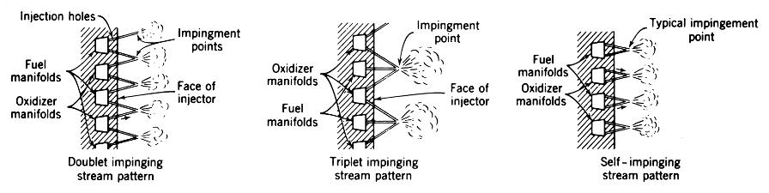

Figure 1. Comparison of Impingement Methods

As of now, the doublet impinging design is the method being pursued because it is easier to control the point of impingement with multiple holes rather than just one hole. Having a greater angle of contact from the doublet design should also result in greater atomization as all of the oxidizer will be hitting at the specified angle and not just some. With this general design being pursued, the most optimal approach involves injecting the oxidizer to a “stable” point. While this can be accomplished with a minimum of three injector holes, four injector holes should inject evenly even if one of the holes is slightly off. This means doing a design like the one seen in Figure 2. Even if the injector is not placed in the center of the combustion chamber, multiple of these four-holed injector coins can be used.

Figure 2. Four Holed Injector Design

**Injector Sizing**

Once the injector design has been finished, the calculations for the injector can be done. This can be done under ideal circumstances using a modified Bernoulli equation and by treating the injector as an orifice. When rearranged to find the equivalent total area of the orifices, the equation becomes

Equation 1. Rearranged Modified Bernoulli Equation

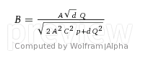

Where B is the area of the orifice, A is the area of the channel, d is the density of the fluid, Q is the mass flow rate, C is the discharge coefficient, and p is the delta pressure across the orifice. This will yield a very crude number given that the injector is infinitely thin and ideal. In reality, friction forces through the holes will be substantial. This along with other non-idealities and the effect of the acceleration of the rocket on the mass flow rate is still being calculated. This finalized number will greatly depend on the final design of the plumbing leading up to the injector as it is expected to have a large coefficient of friction. Due to the high pressure drop (about 75% of the delta pressure) expected from the new plumbing/injector design the oxidizer should be completely vaporized by the time it gets to the combustion chamber. This simplifies calculations, makes the vehicle more predictable, and ultimately allows better control of the mass flow rate.

**Tank Filling**

It was originally thought that by filling the tank with oxidizer, letting some boil off to cool the temperature and then refilling the oxidizer would greatly benefit the vehicle as the colder nitrous oxide would be much denser and allow the vehicle to carry more. Unfortunately, due to the nature of the way the nitrous is purchased from Praxair (in 64 lb type k cylinders) the tank of the vehicle can only fill up with a maximum nitrous oxide mass of about 10.88 lbs. This means that given the 10 lbs that are needed, only about .88 lbs can be boiled off. This results in a very small change in overall enthalpy (about 70,000 ft*lbf out of about 855,000 ft*lbf) and thus a very small change in the temperature and density of the oxidizer.

**Injector Size**

1. "F-1 Engine Injector." *F-1 Engine Injector*. N.p., n.d. Web. 21 Oct. 2014.
2. 2000-3871, Aiaa, and Page 1 Of 22. *TRW Pintle Engine Heritage and Performance Characteristics* (n.d.): n. pag. Web.
3. "Flowrate Calculation for an Orifice Flowmeter." *Flowrate Calculation for an Orifice Flowmeter*. N.p., n.d. Web. 21 Oct. 2014.